PLAN

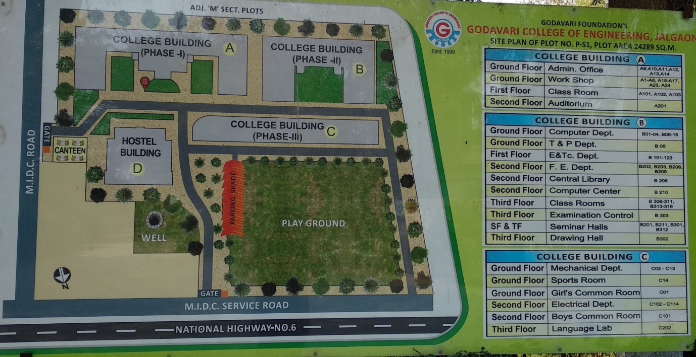

Infrastructure

Sr. No. | Facility | No. | Total Area in Sq. m.
1 | Class Room (UG18+PG3) | 21 | 1668.47
2 | Tutorial Room | 03 | 114.37
3 | Laboratory (36+08) | 44 | 3461.62
4 | Workshop | 12 | 1320.48
6 | Computer Centre | 01 | 155.5
7 | Drawing Hall | 01 | 130.03
8 | Library & reading room | 01 | 492.76
9 | Seminar Room | 05 | 895.23
10 | Common Room | 03 | 230.58
11 | Sports Room & Gym | 01 | 70.9
12 | Total Carpet up Area |  | 24289

Outdoor Games and Indoor Games

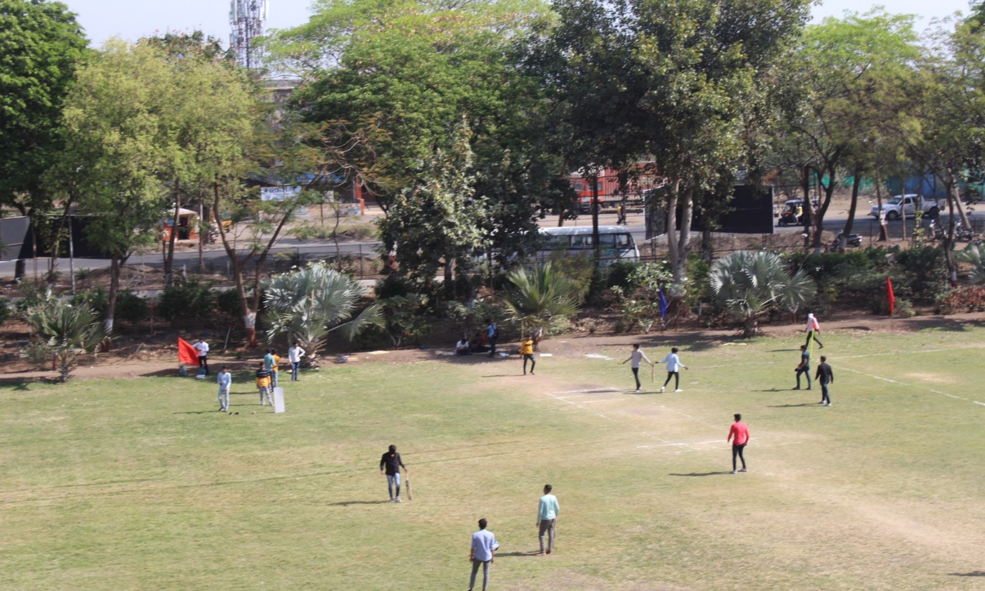

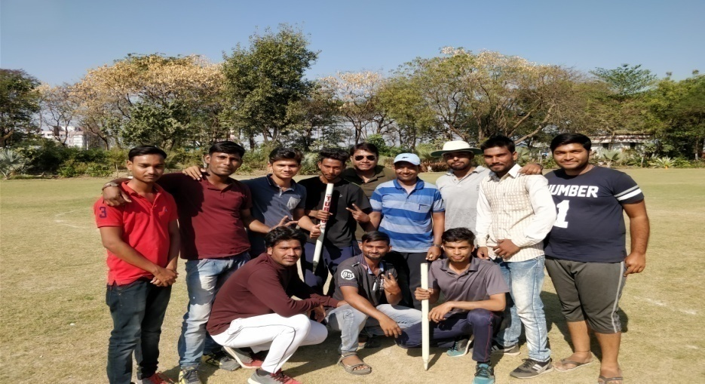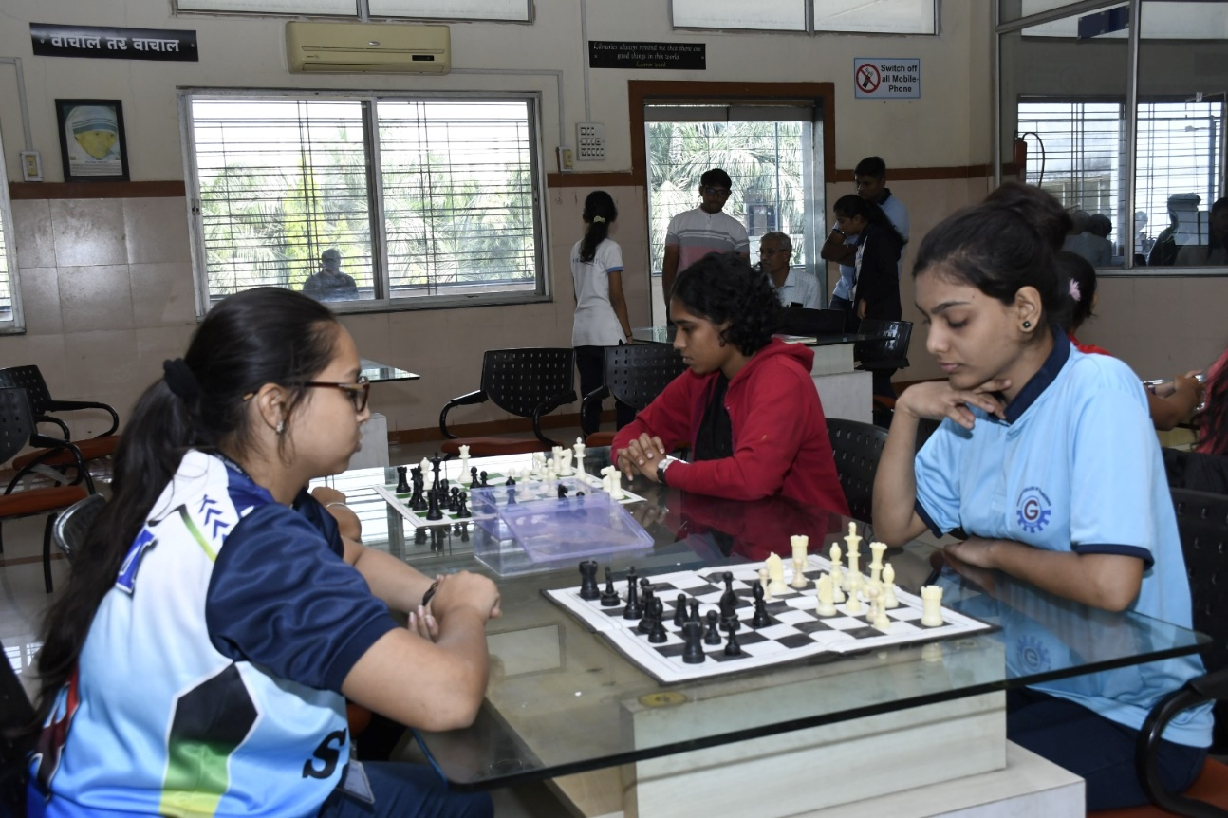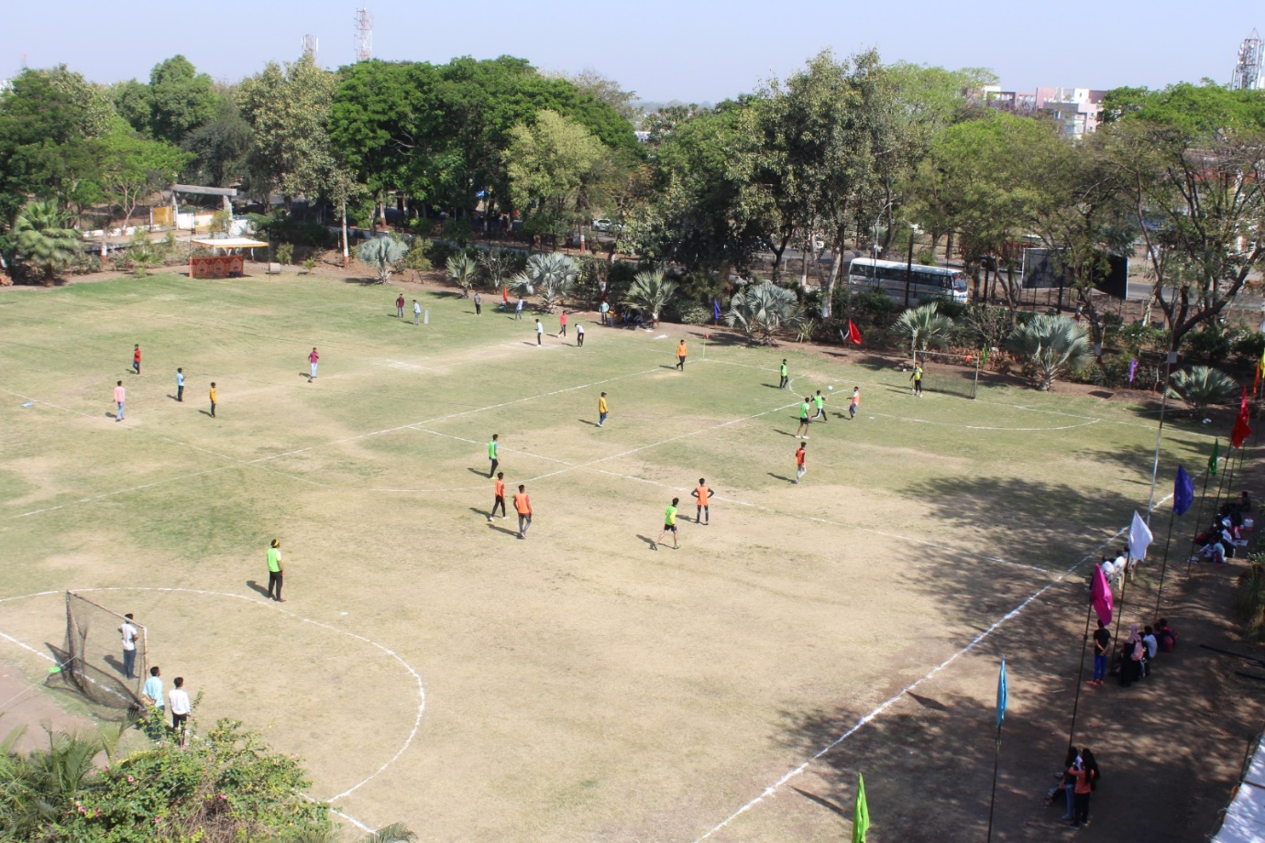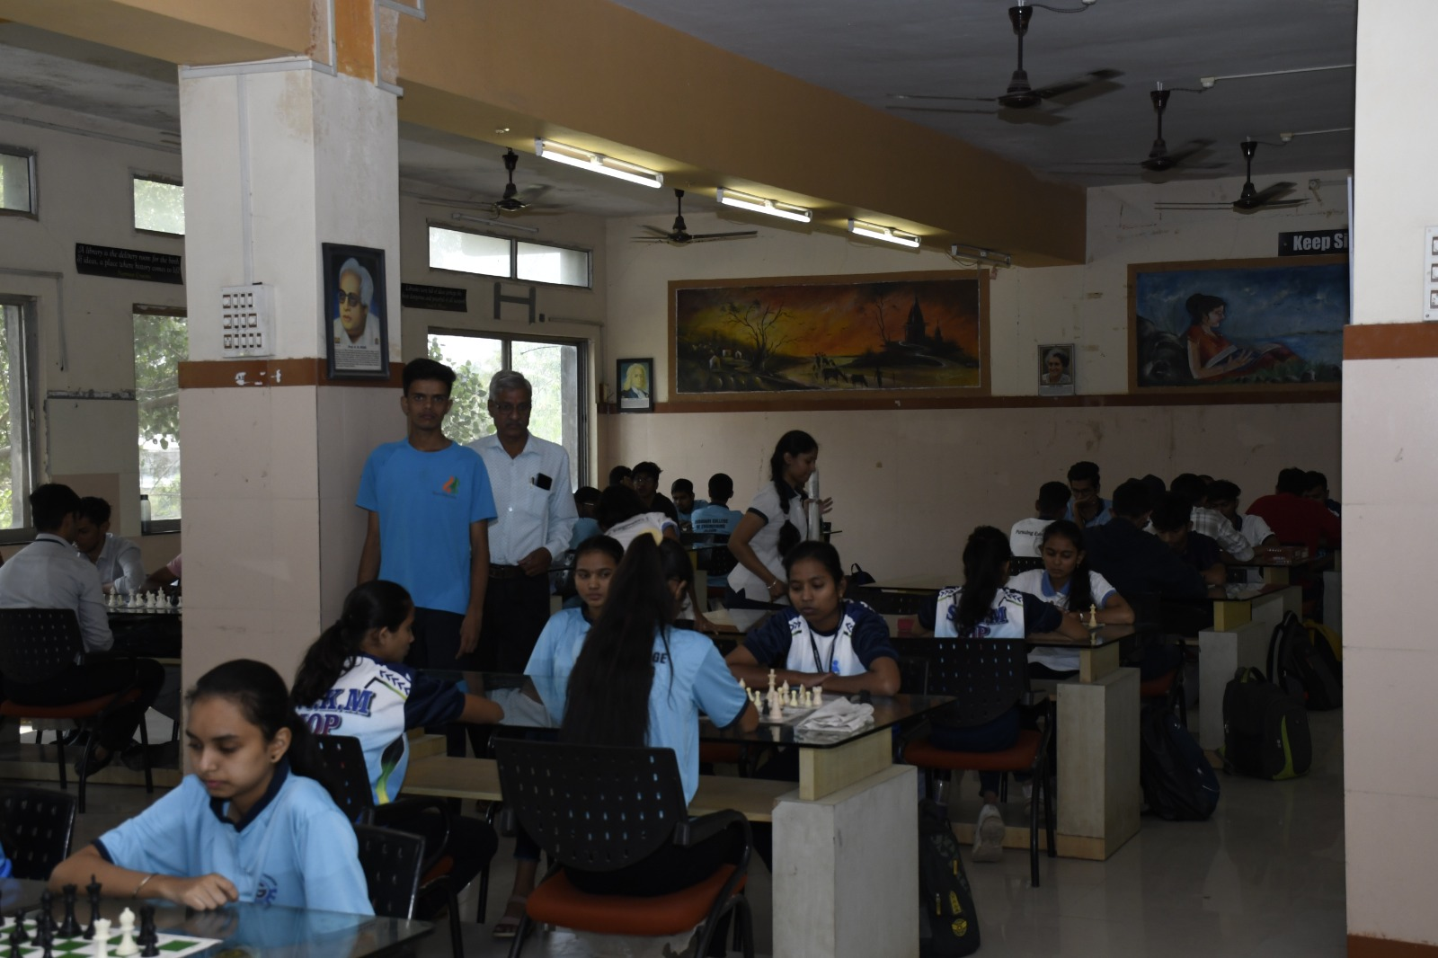

Culture activities for college students
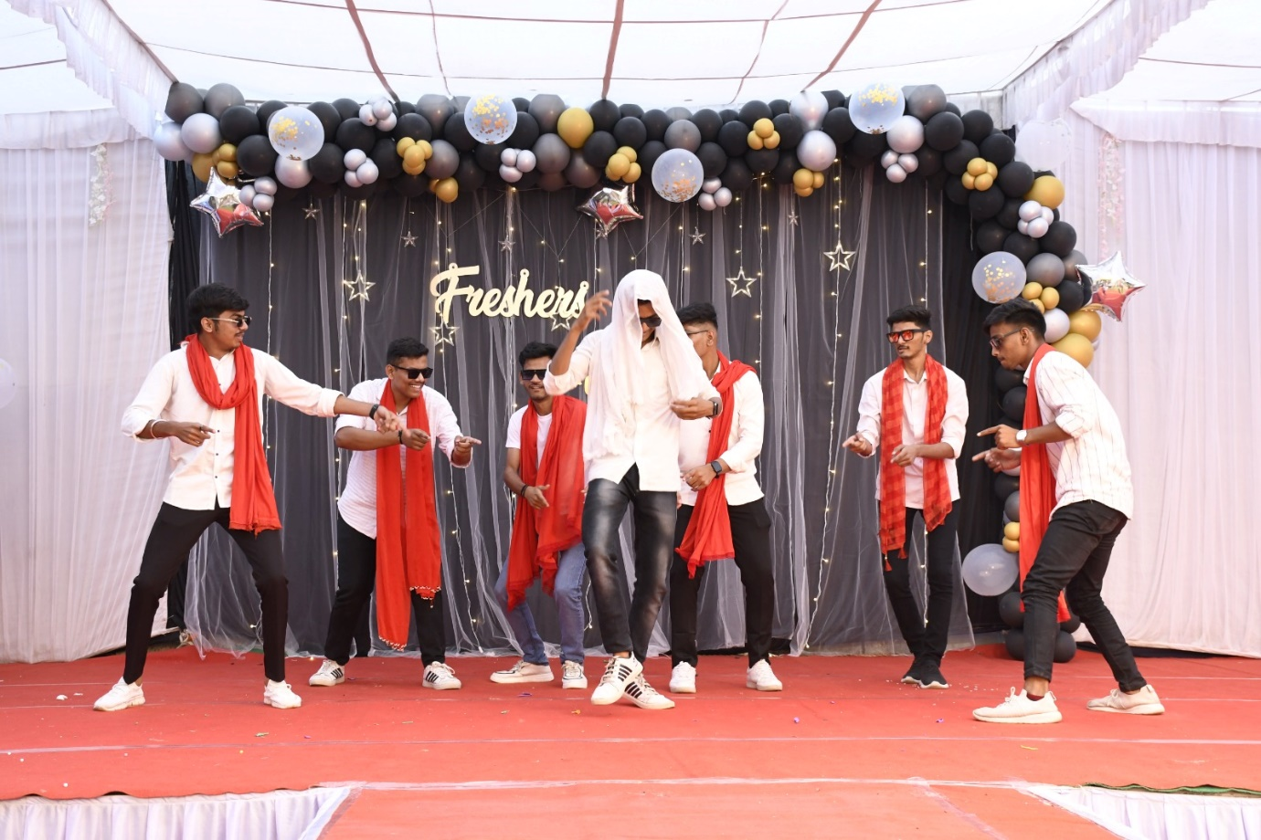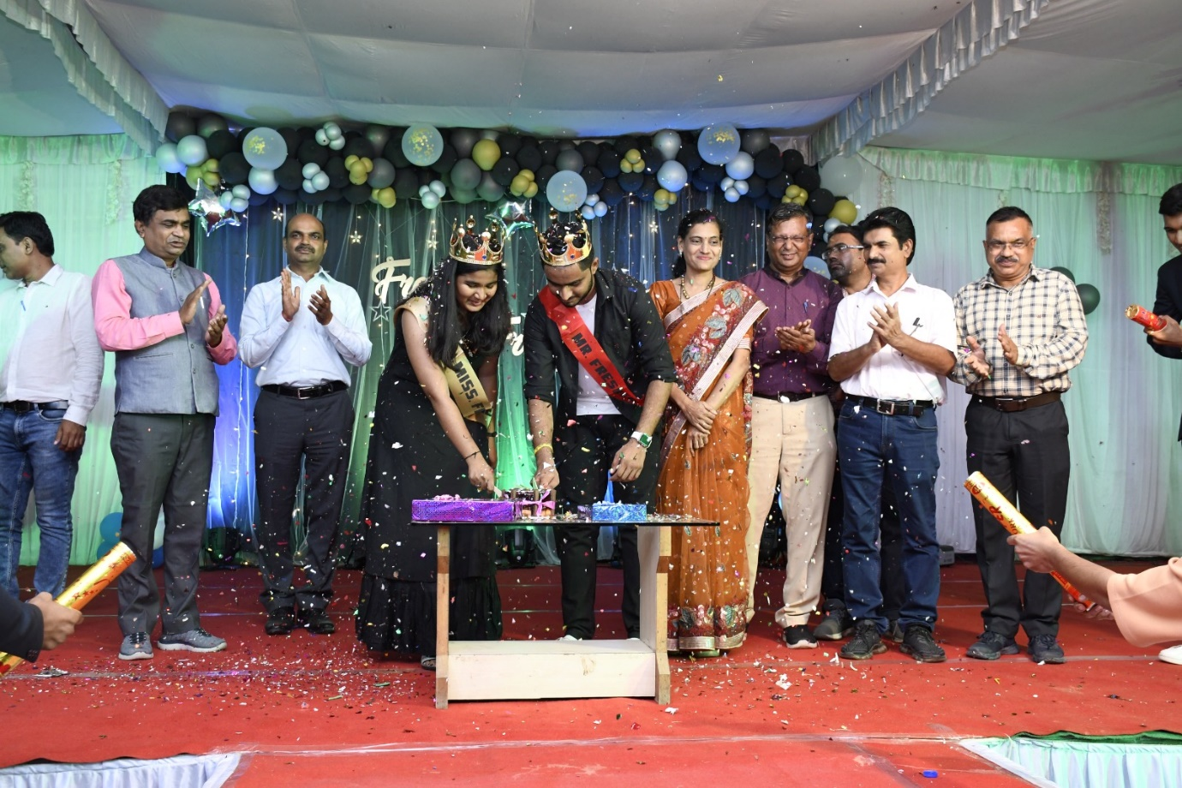

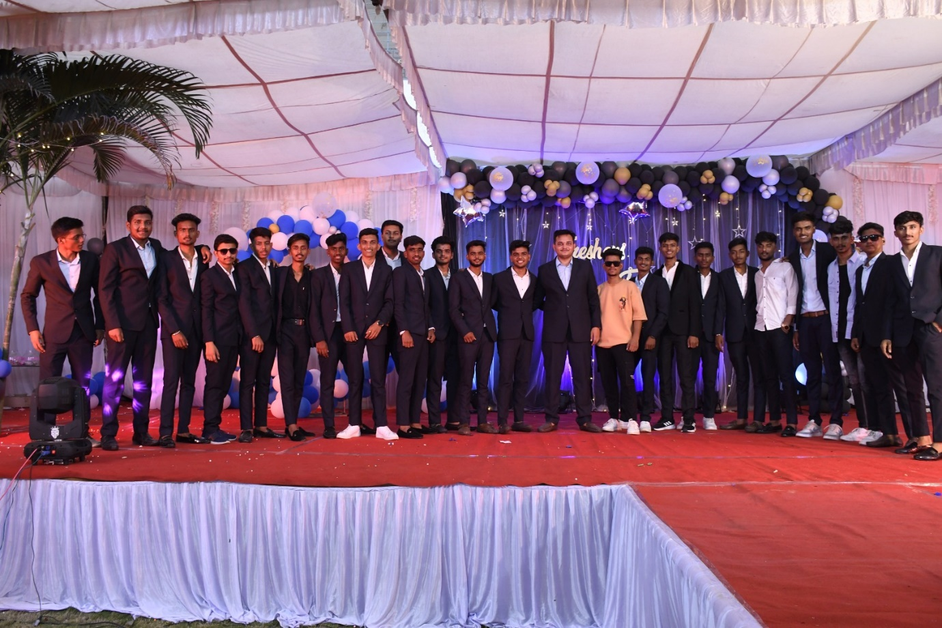

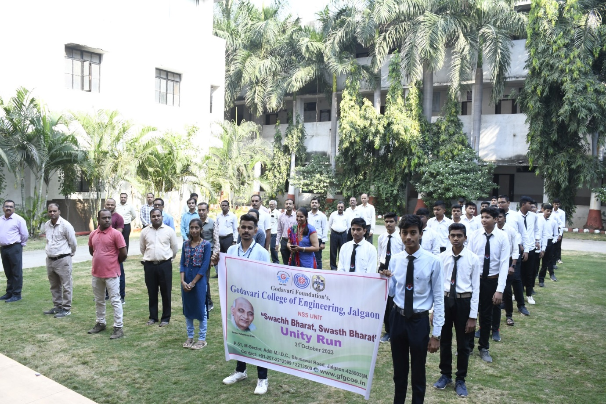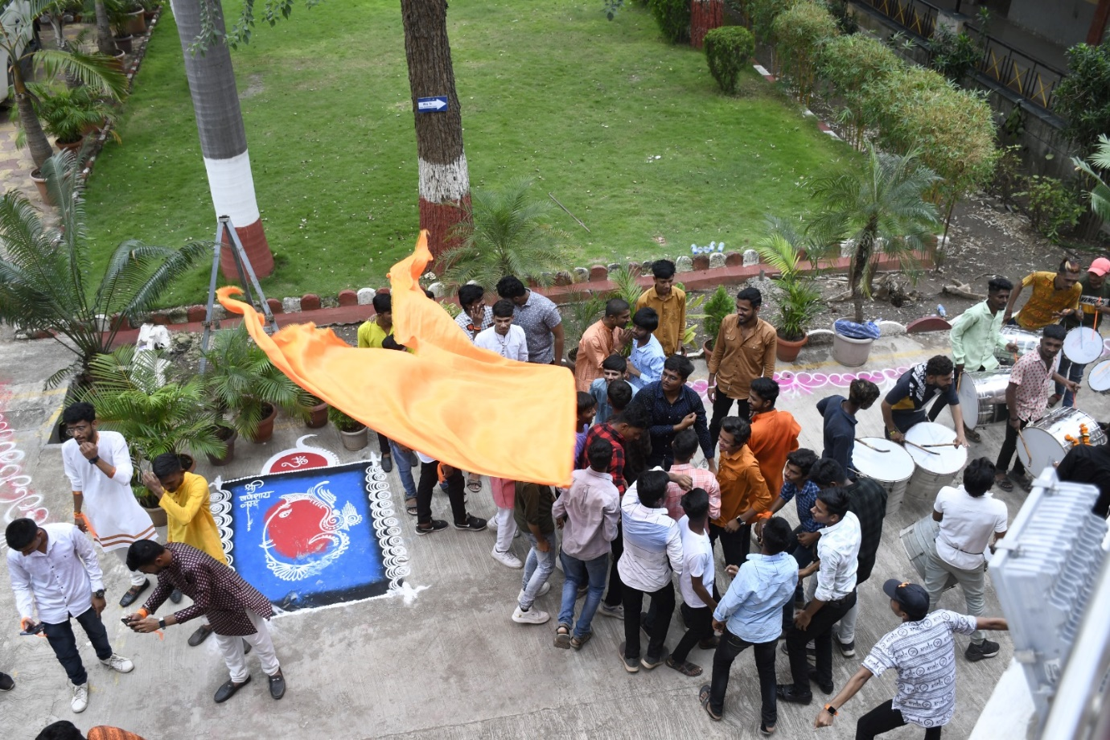
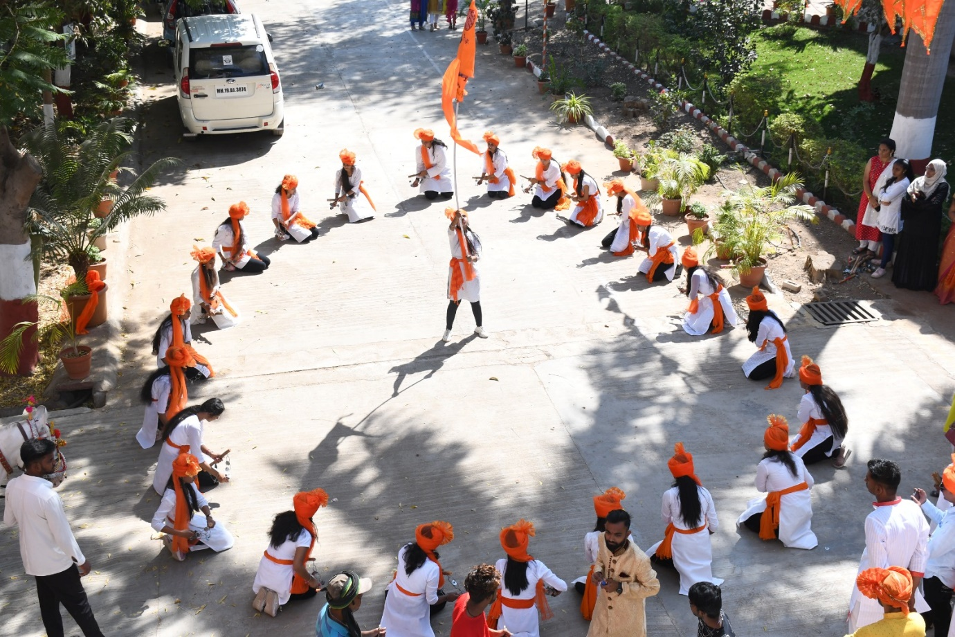

Sr. No. | Particulars | Total Count
1 | No. of Computers | 300
2 | No. of Laptops | 40
3 | Printers | 22
4 | Scanners | 6
5 | Projectors | 22
6 | Multifunctional Printers | 06
7 | Bandwidth | 300 Mbps
IT Infrastructure
SR. NO. | DEPT. | COMP. | LAPTOPS | PRINTERS | SCANNERS | PROJECTORS | MF Printer
1 | COMPUTER | 120 | 07 | 09 | 01
2 | ELECTRICAL | 20 | 02 | 01 | 01
3 | E&TC | 20 | 25 | 02 | 01
4 | MECHANICAL | 20 | 02 | 01 | 01
4 | FIRST YEAR | 20 | 04 | 01 | -
5 | ADMIN | 10 | 00 | 06 | 01 |  | 05
6 | LIBRARY | 14 | - | 01 | - |  | 01
7 | SERVER | 02 | - | - | -
8 | Comp Center | 52 |  | 01 | 01

Central Library and Reading Room
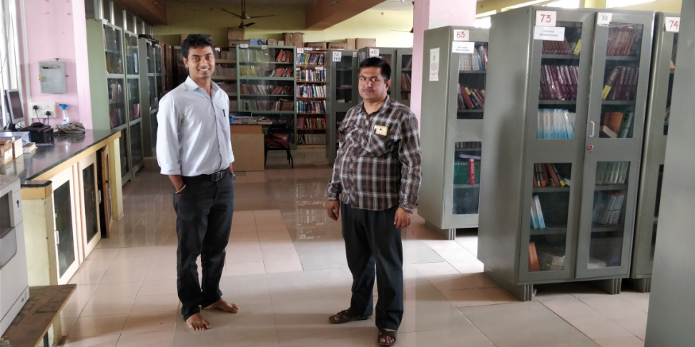

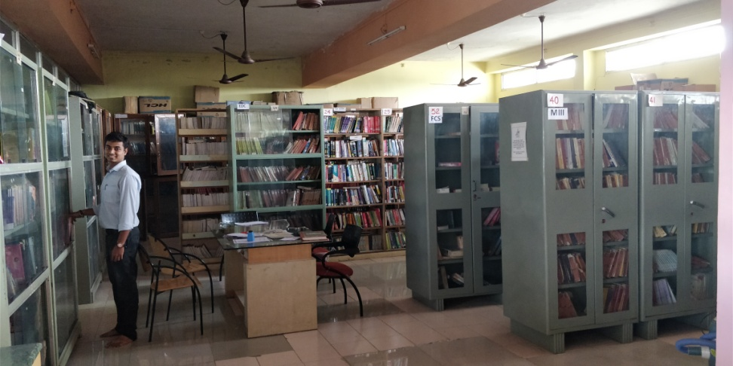
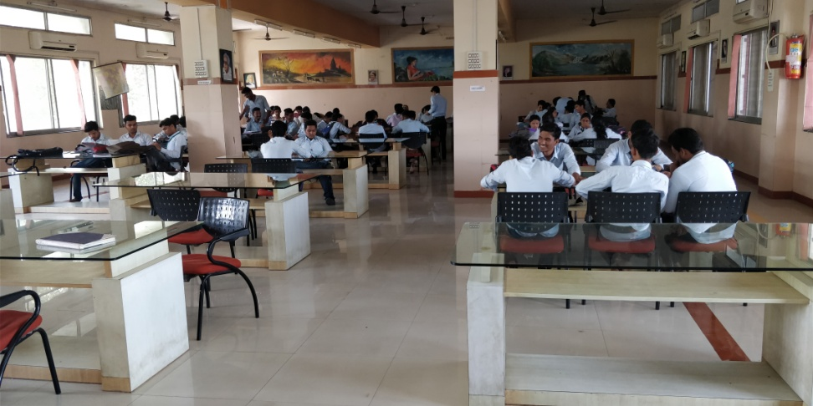

Labs at Various Departments
COMPUTER NETWORK
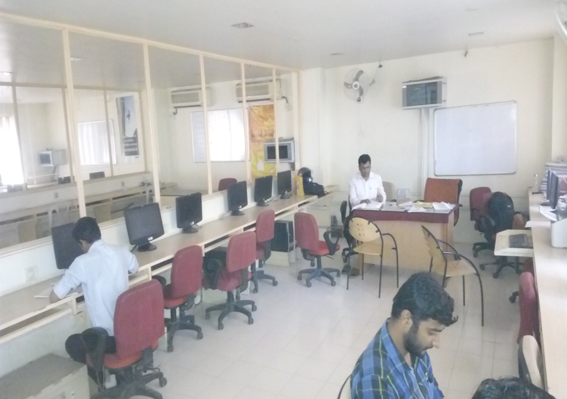

DATA STRUCURE LAB
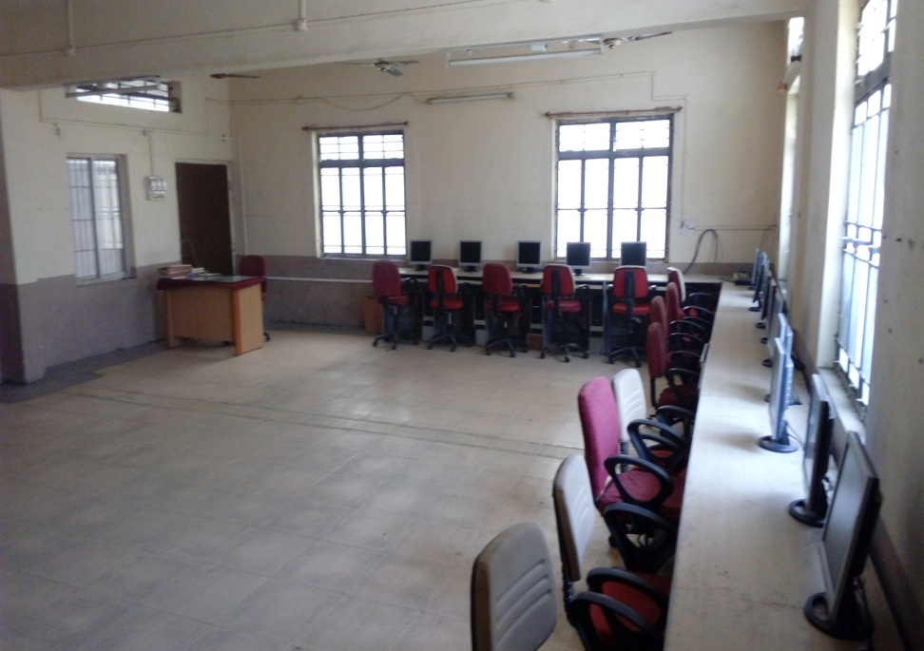

DBMS LAB
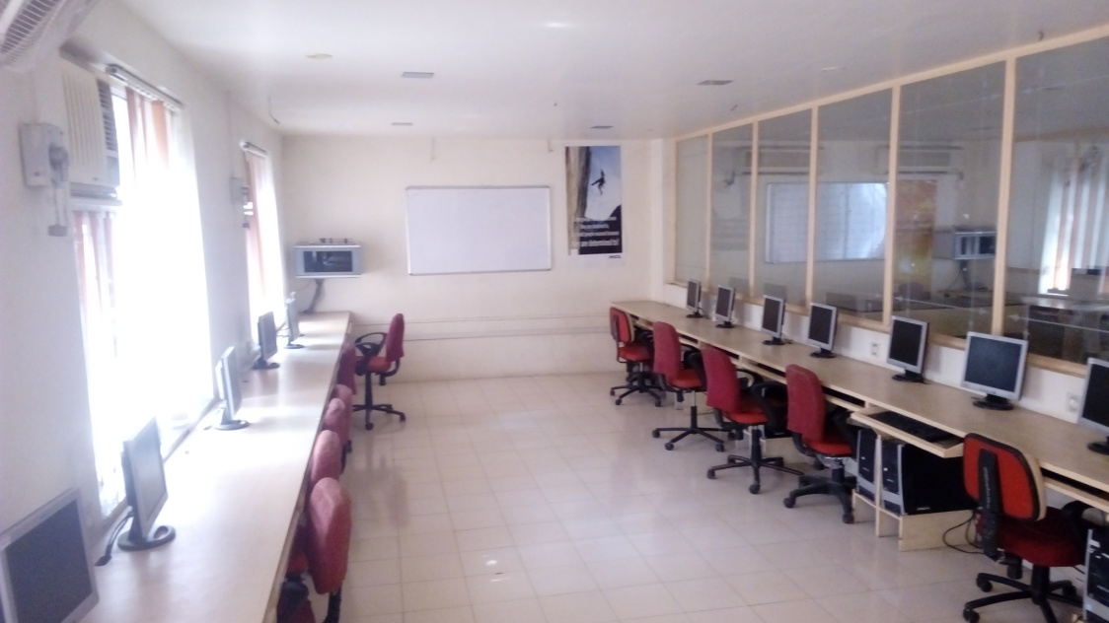

LINUX LAB
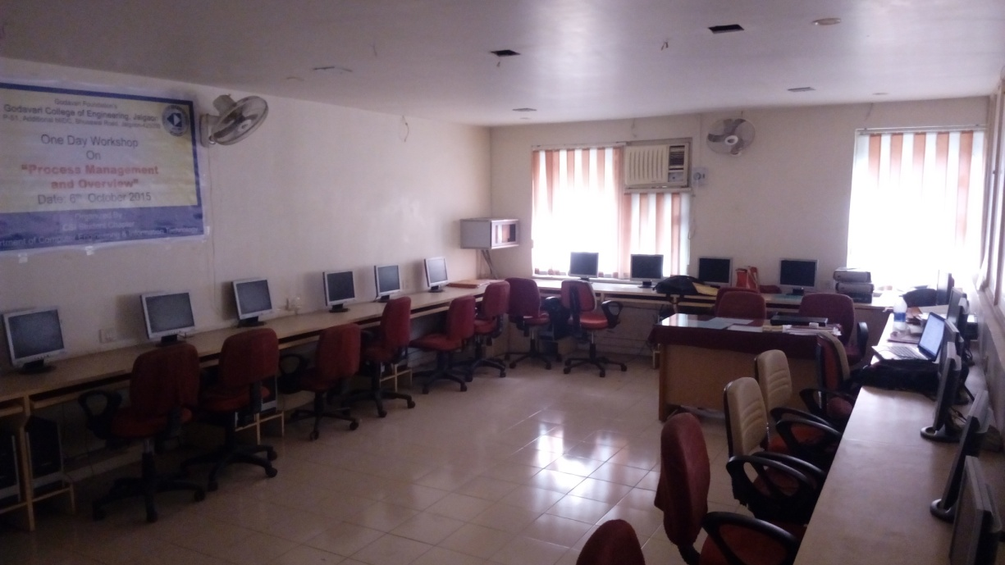

SOFTWARE ENGG
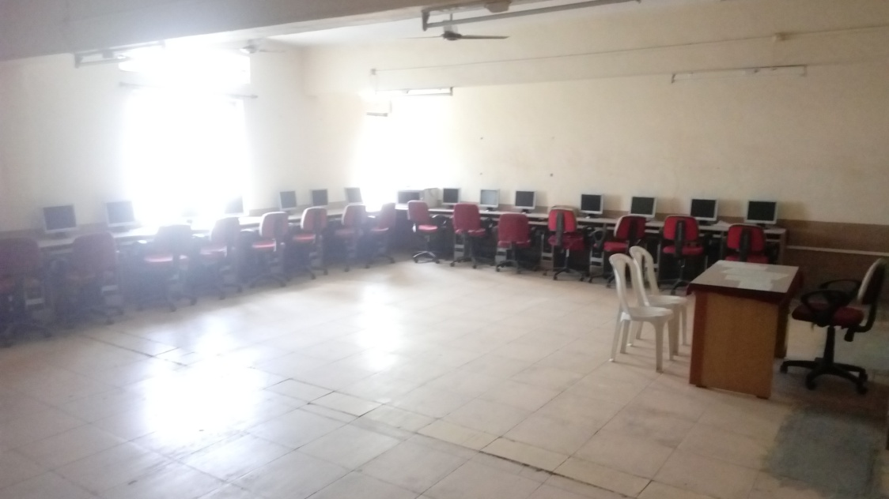

EMBEDDED LAB
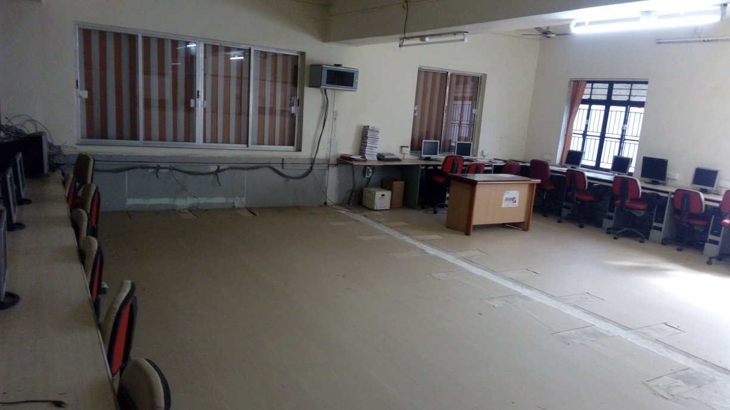
COMPUTER CENTER
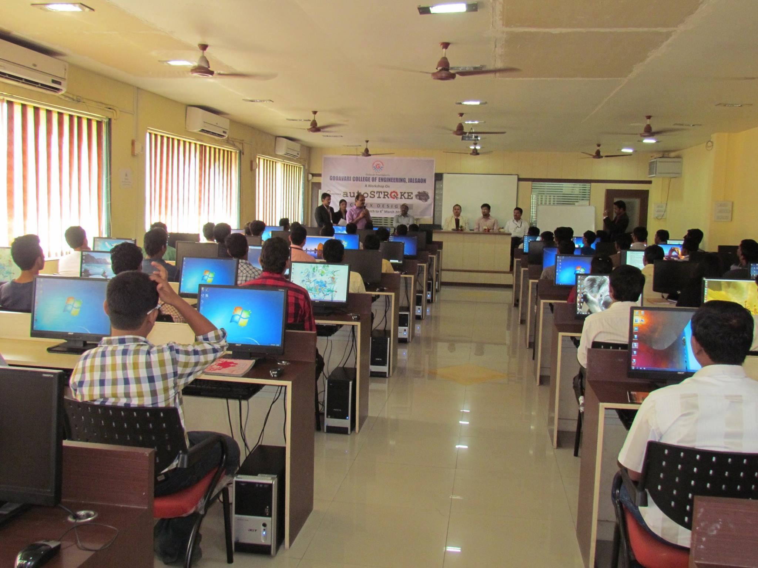

ELECTRICAL DEPARTMENT
COMPUTER LAB
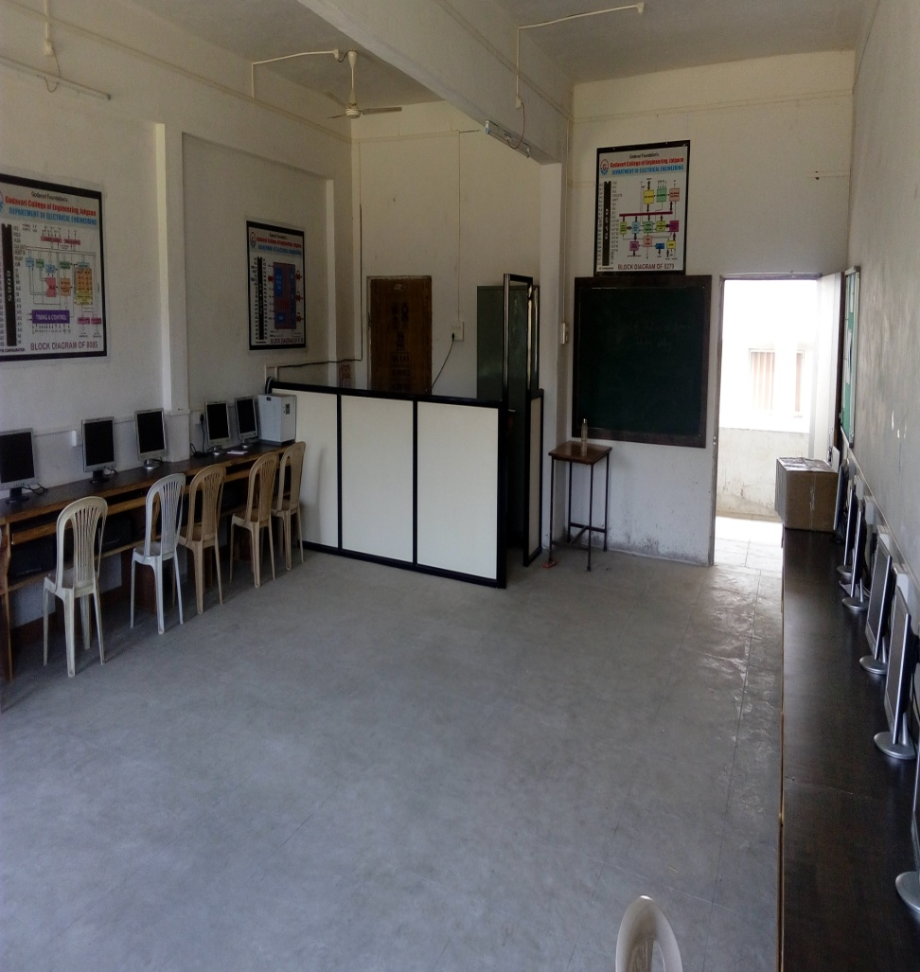

CONTROL SYSTEM
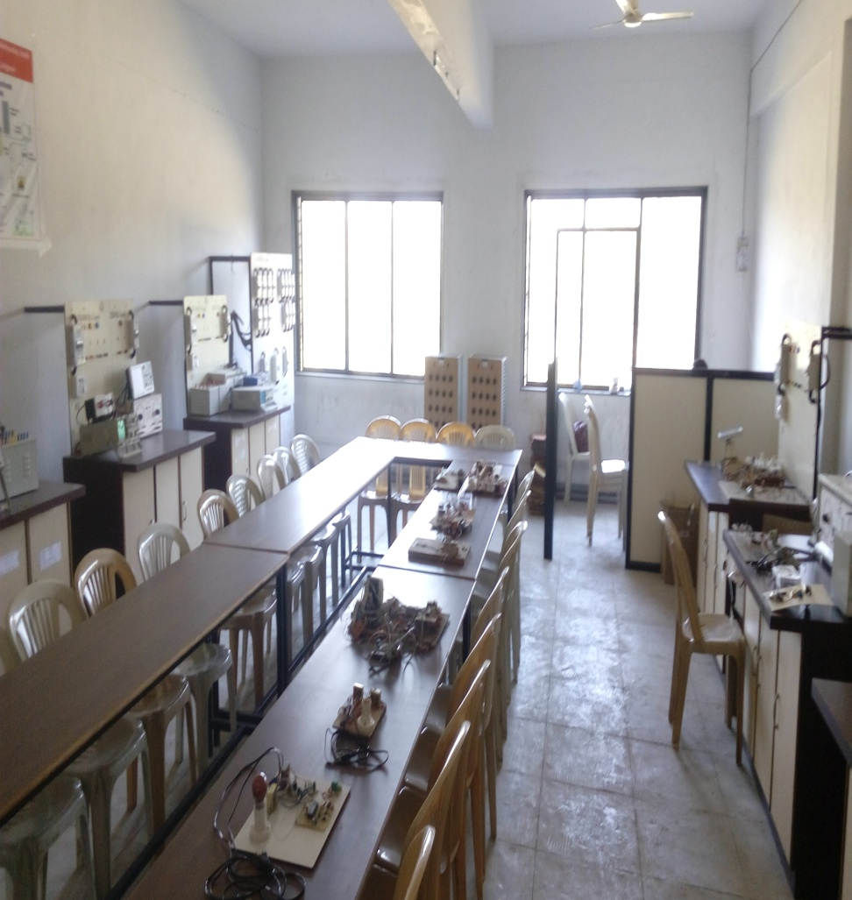
ELECTRICAL MACHINE
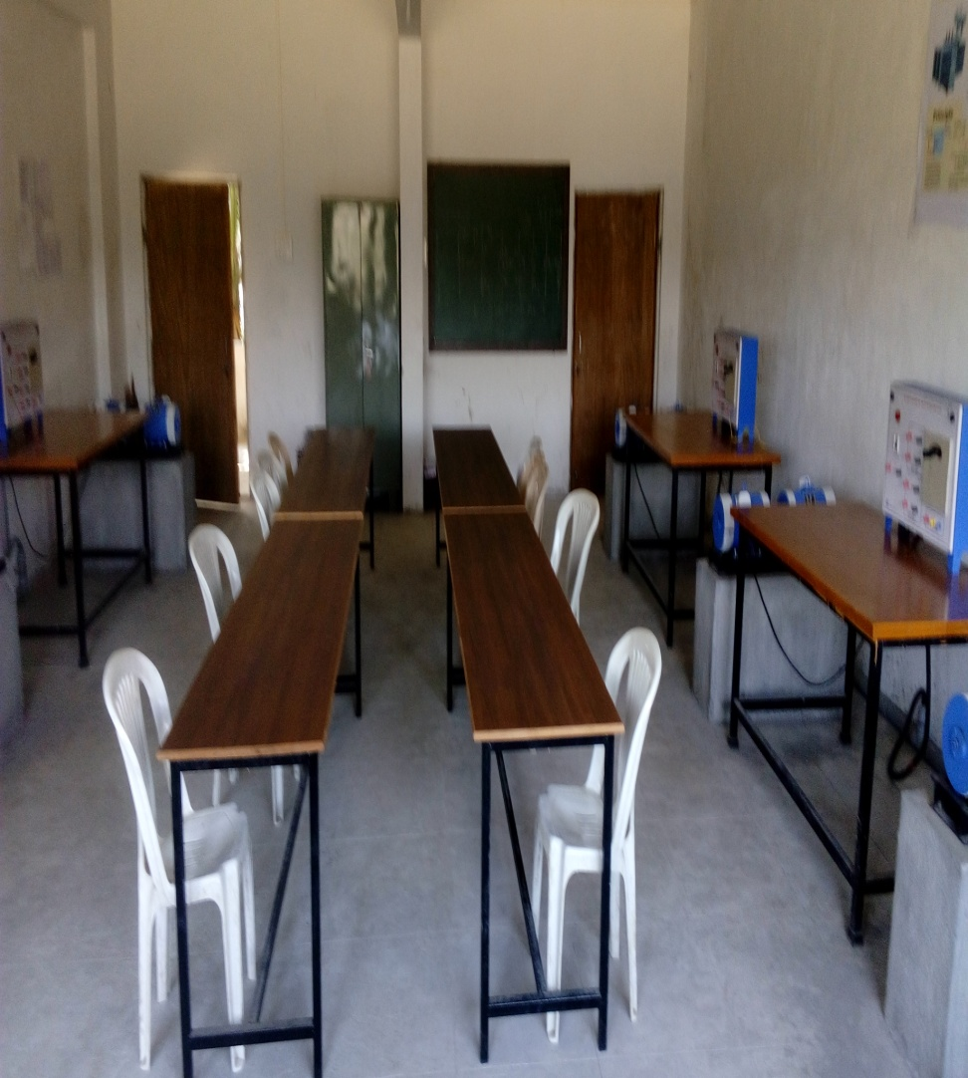
POWER ELECTRONICS
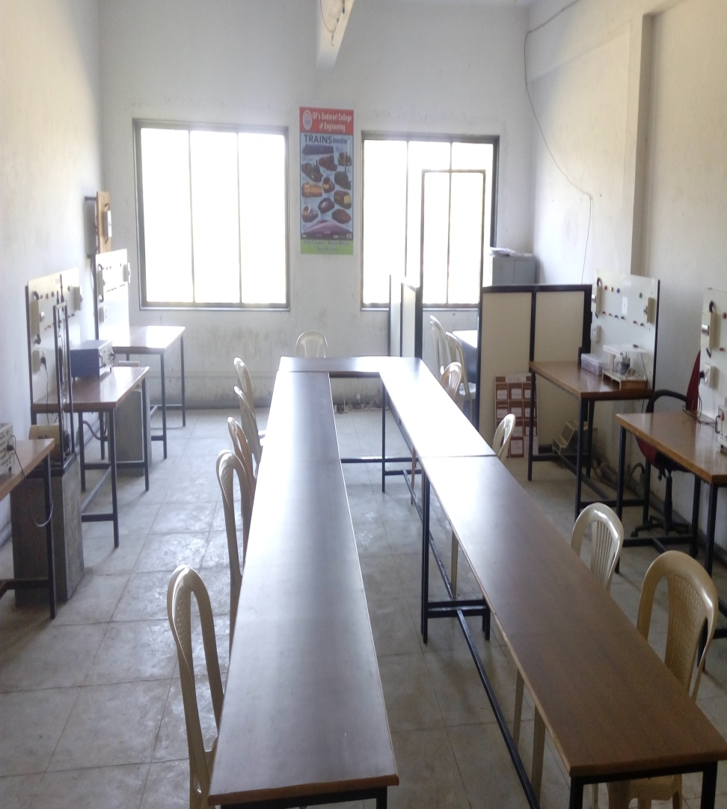

SWITCHGEAR & PROTECTION
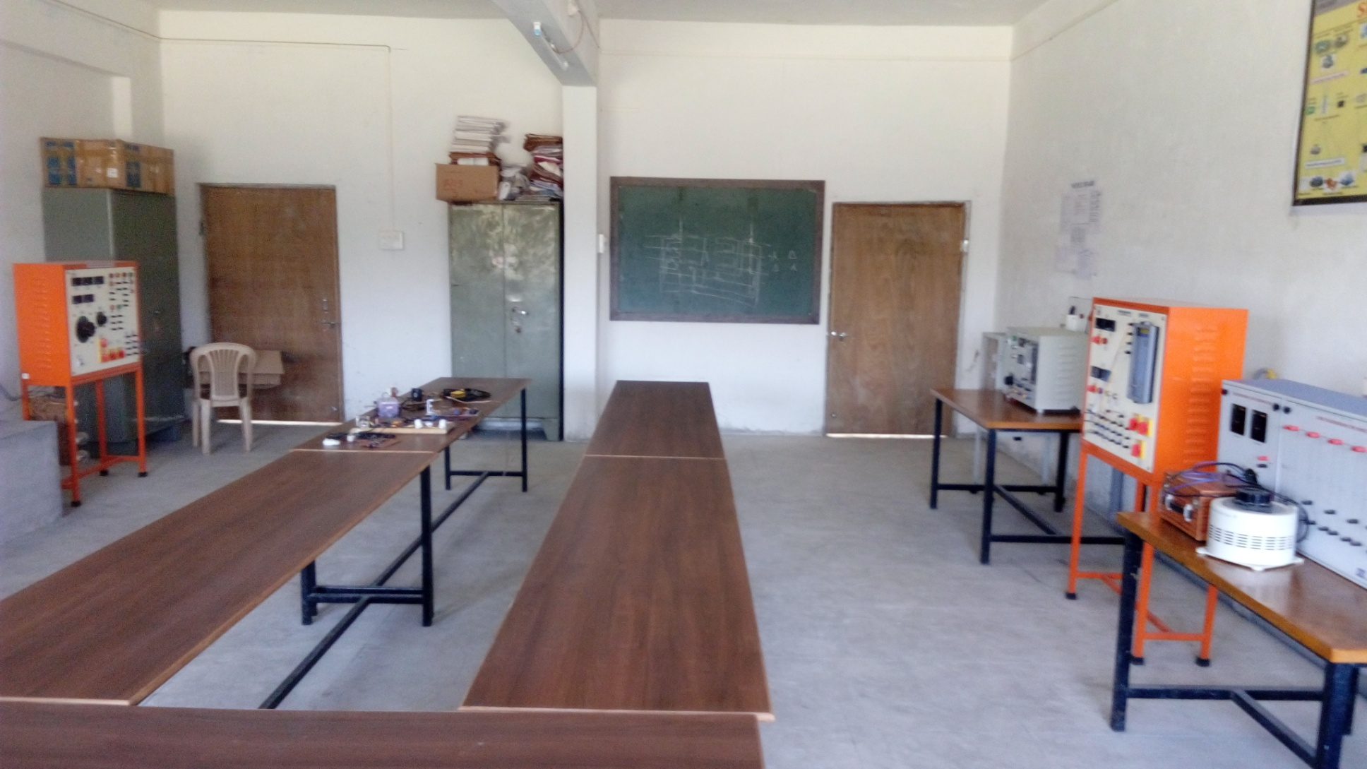
E & TC DEPARTMENT
INSTRUMENTATION AND CONTROL
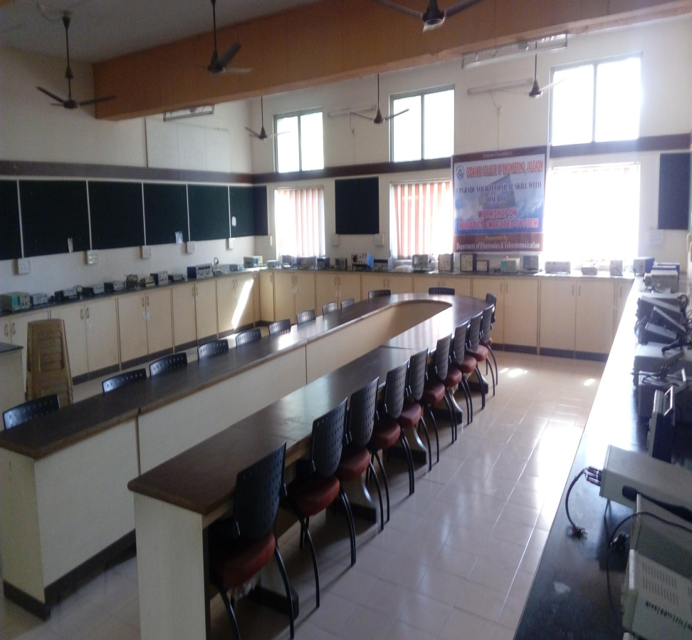
LINEAR ELECRONICS LAB
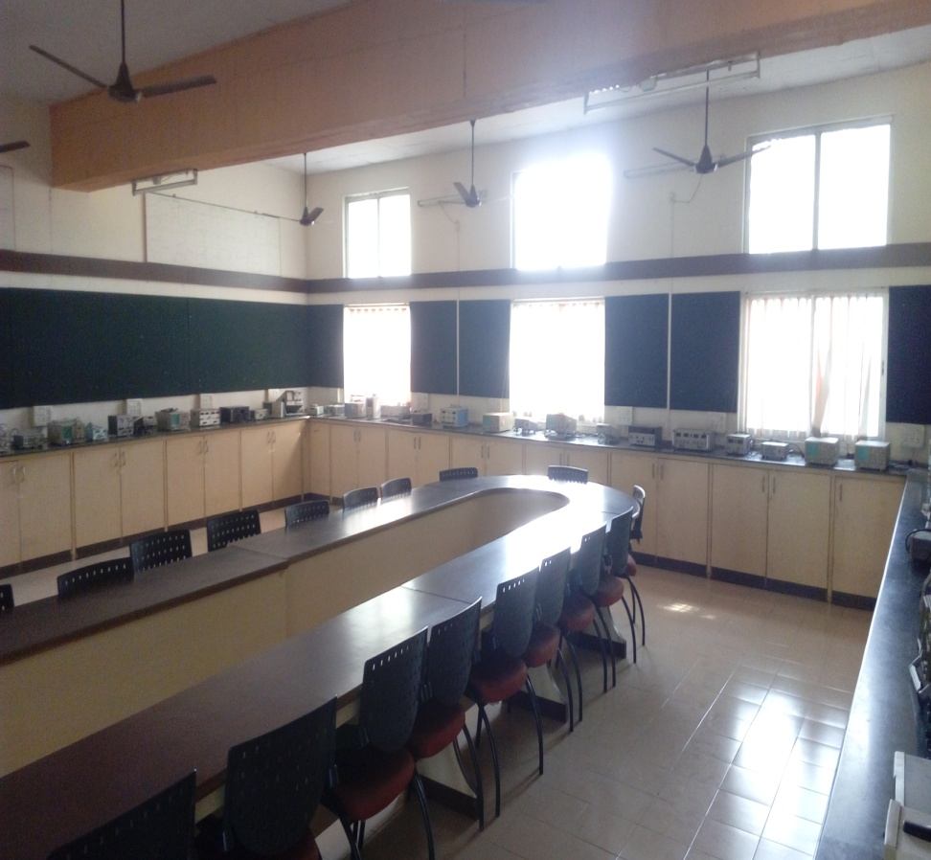
MICROWAVE COMMUNICATION LAB
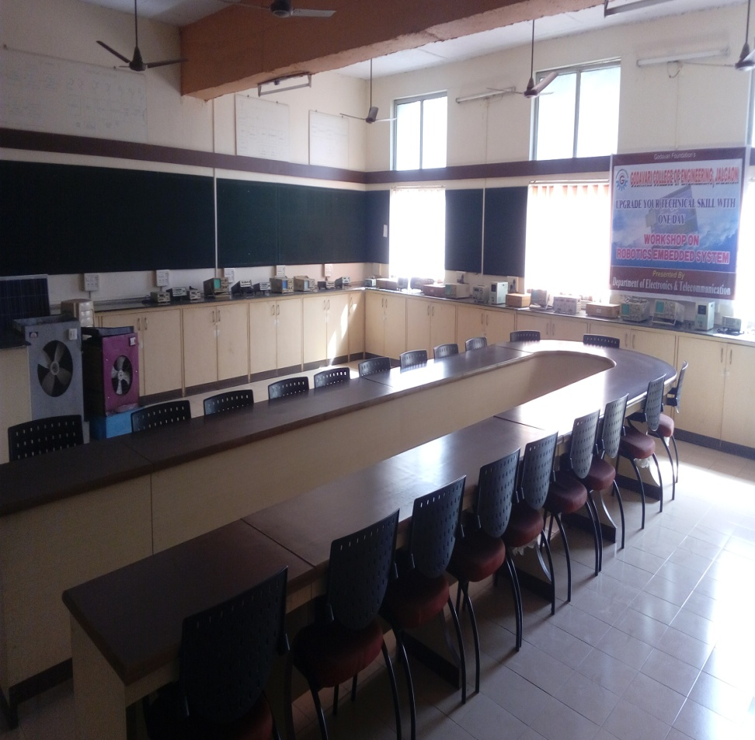

POWER ELECRONICS LAB
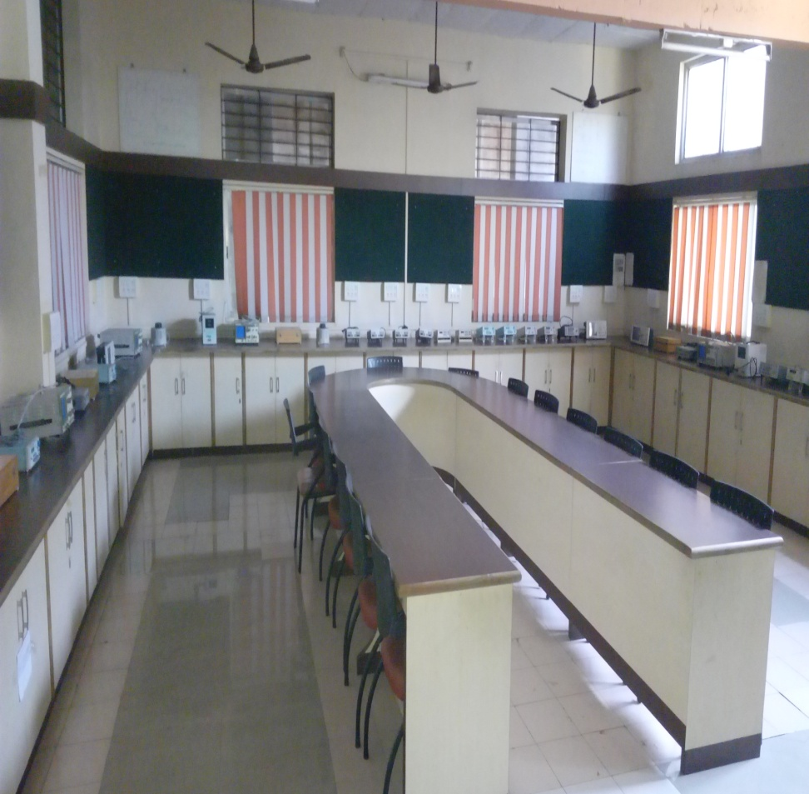
TV.CONSUMER LAB
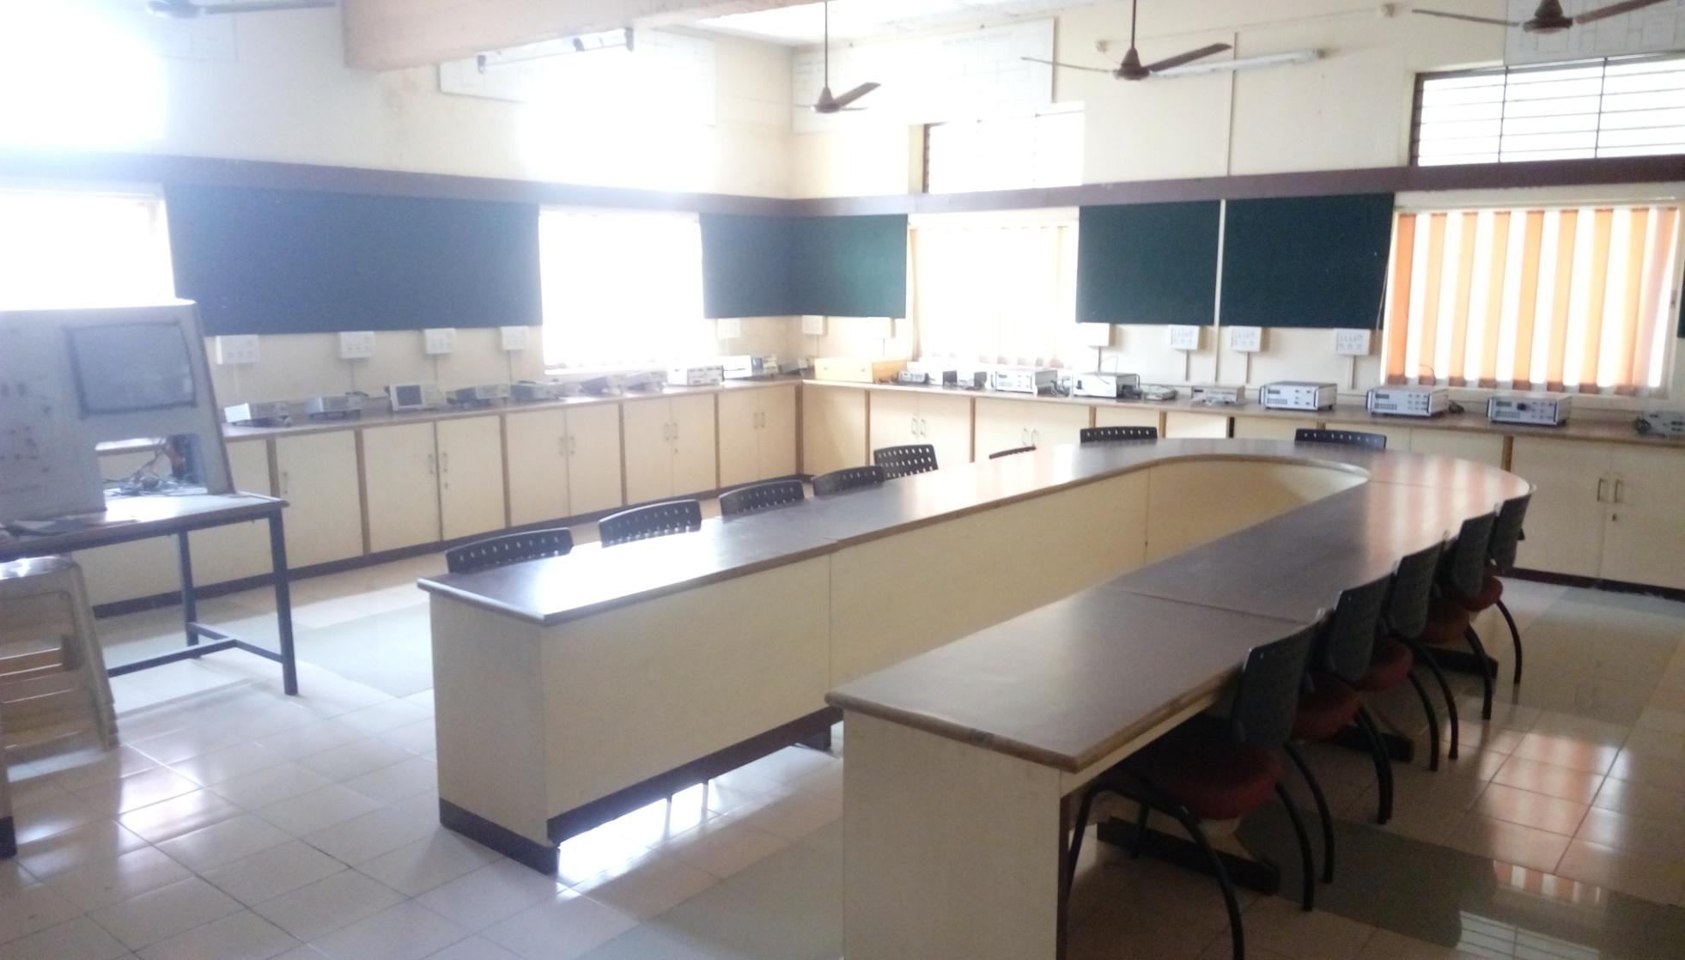

FIRST YEAR LABS
Chemistry Lab

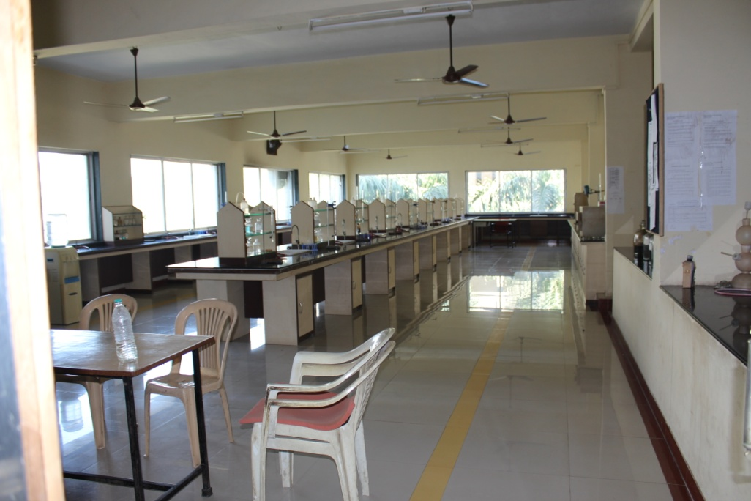

PHYSICS
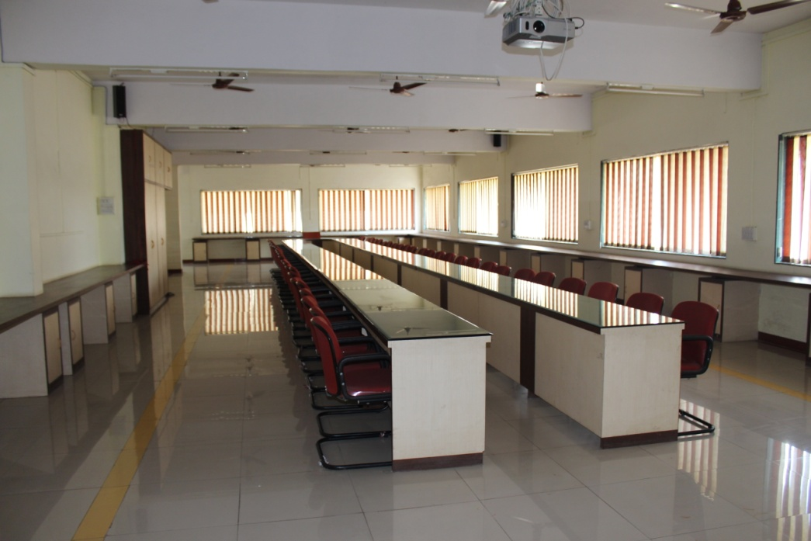

MECHENICAL LAB
APPLIED THERMODYNAMICS
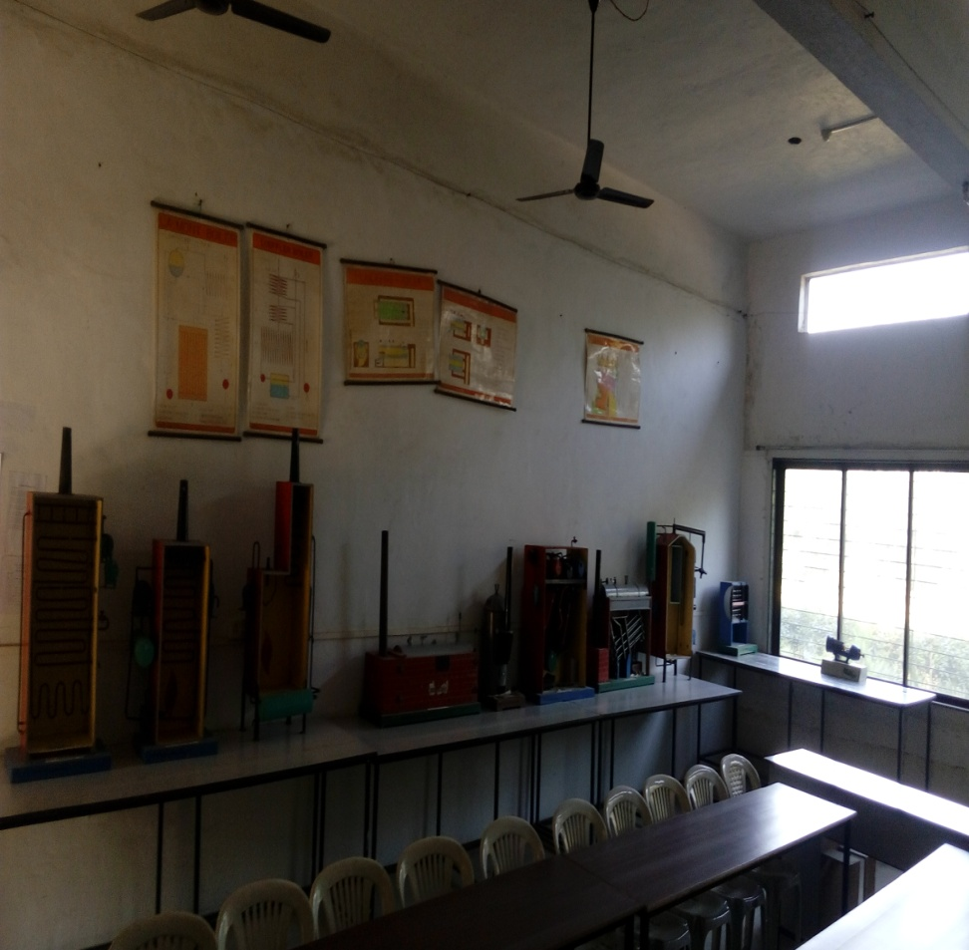

CAD CAM
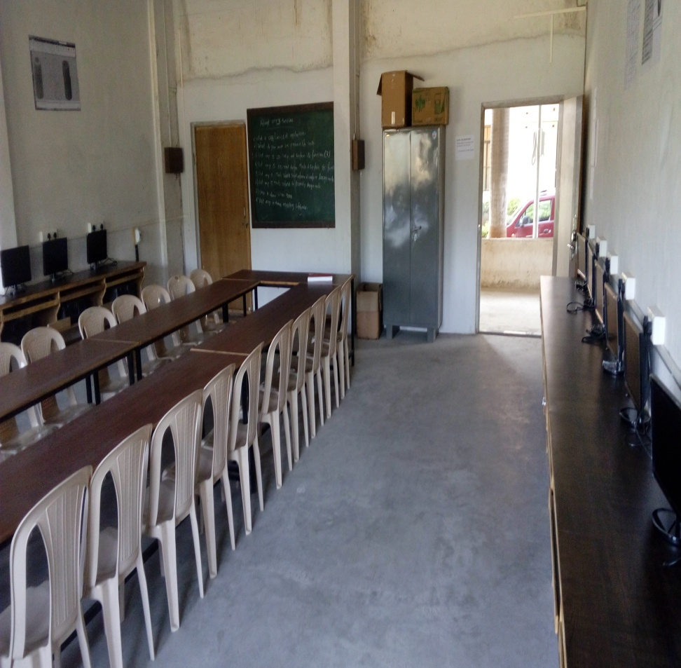
DYNAMICS OF MACHINERY
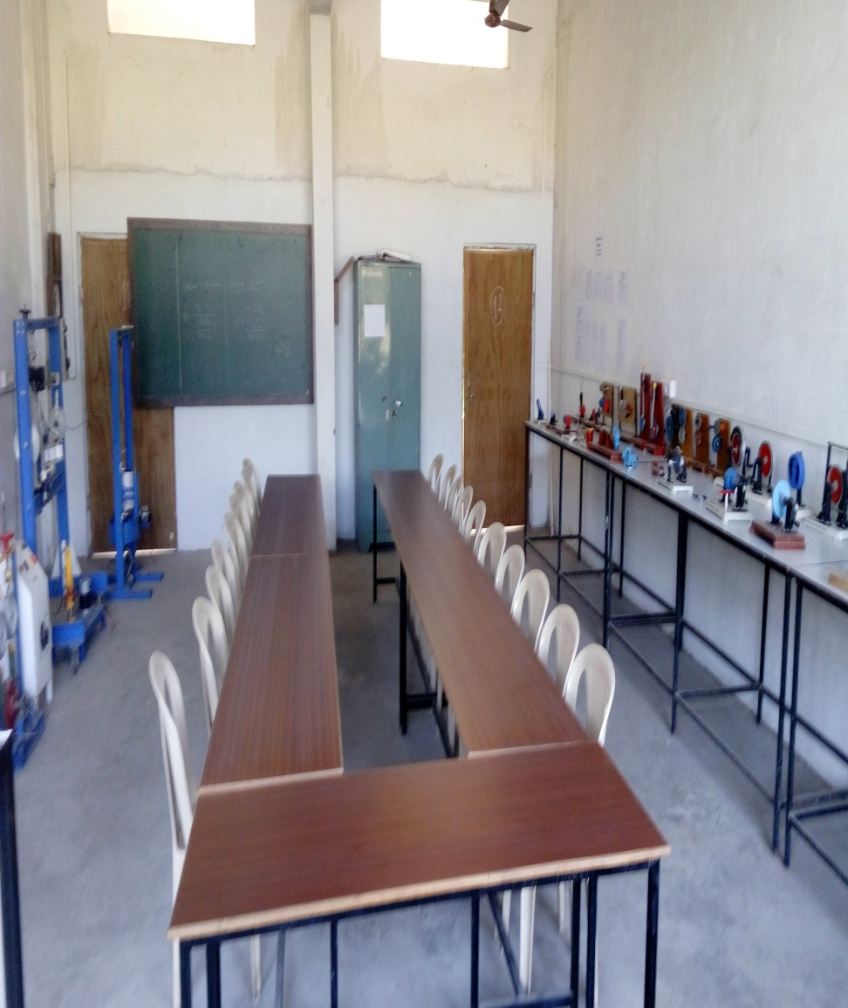
FLUID MACHINERY
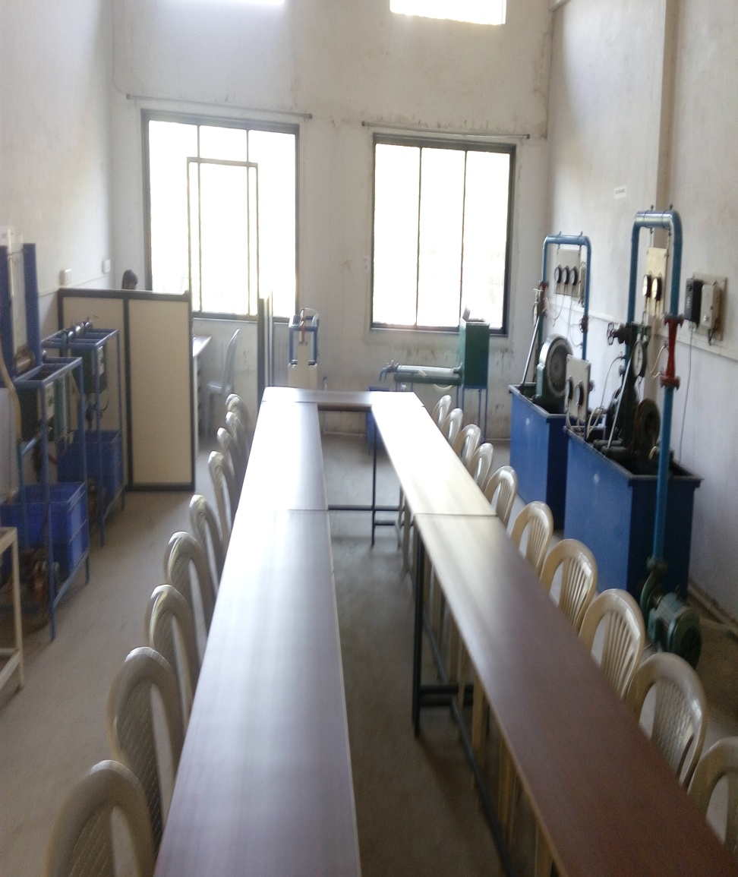

HEAT TRANFER LAB
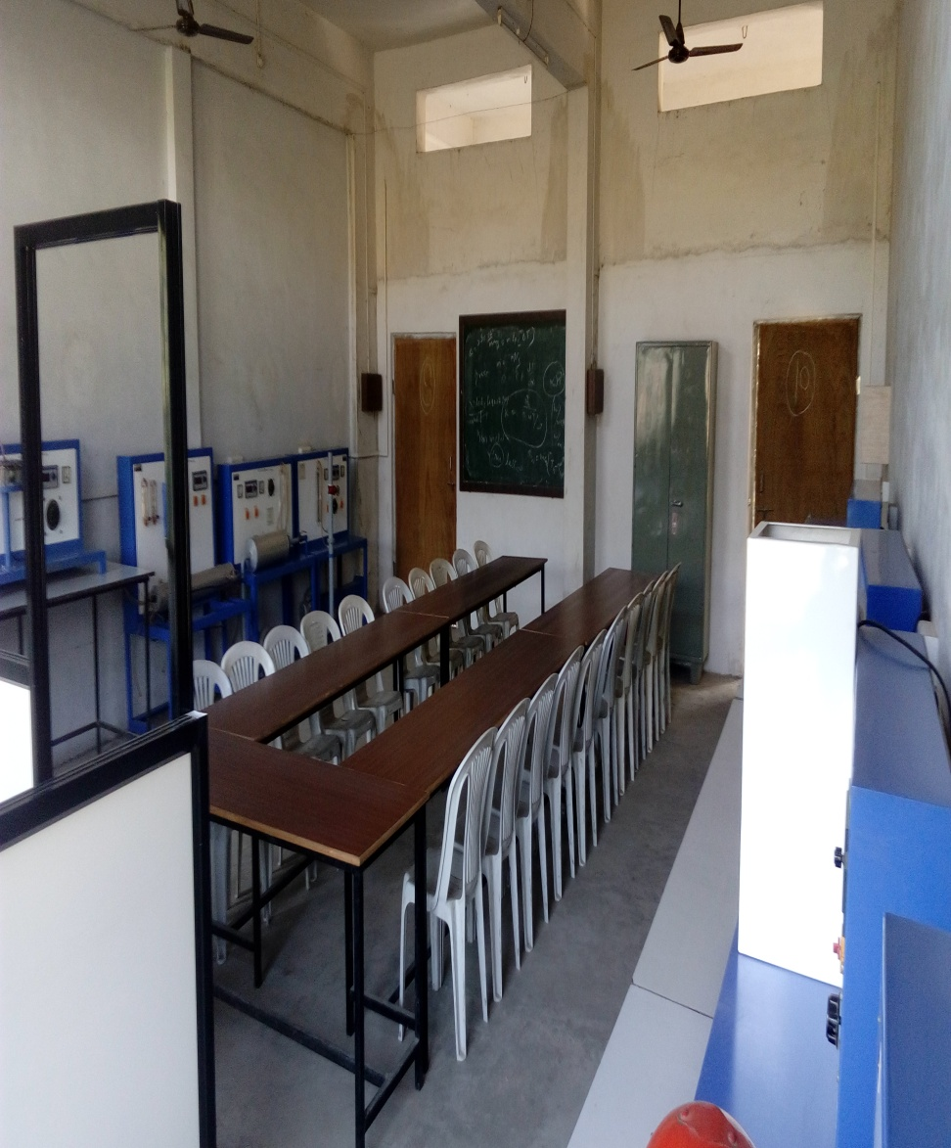

I.C.ENGINE
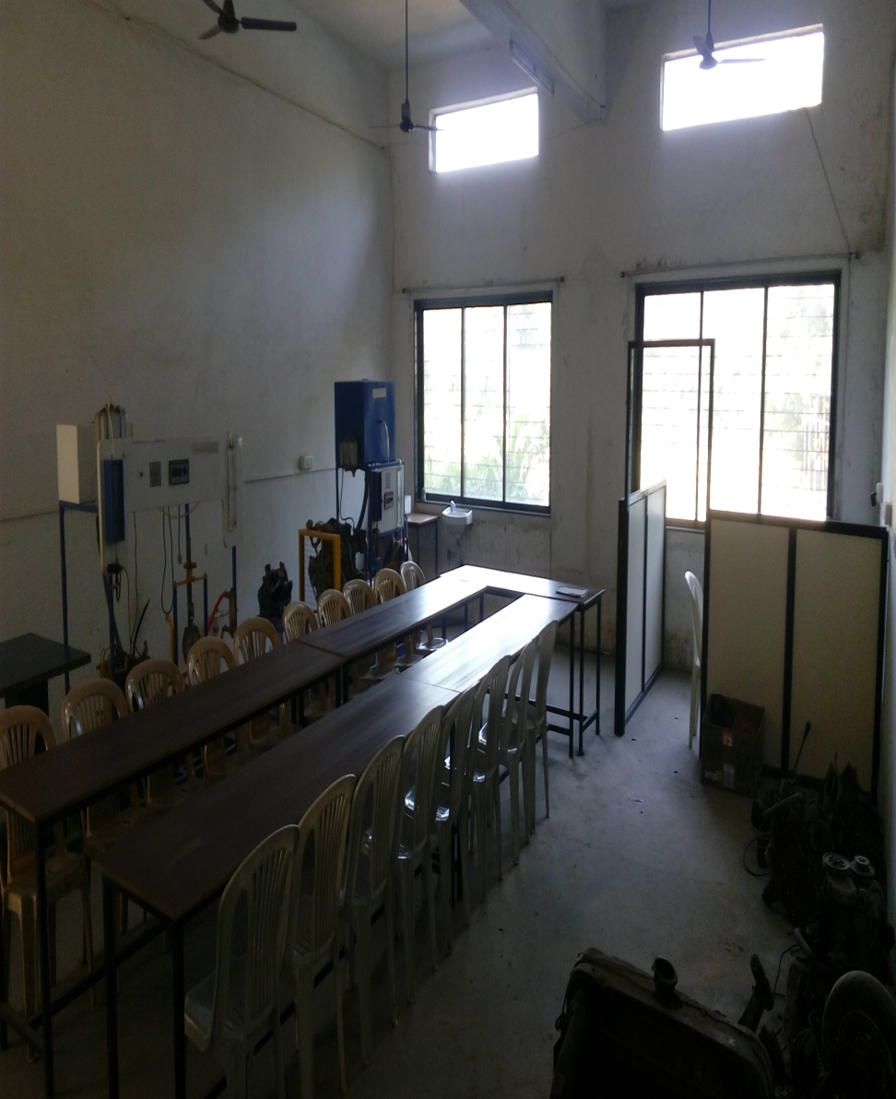
WORKSHOP
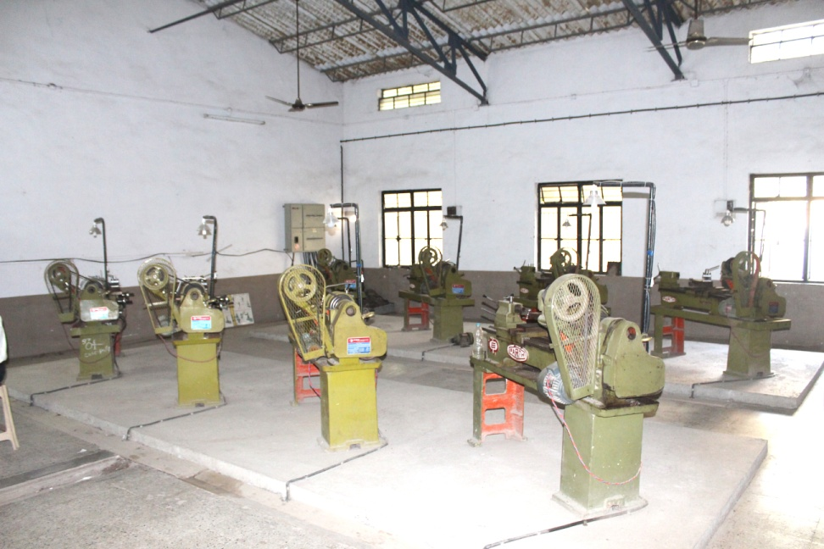
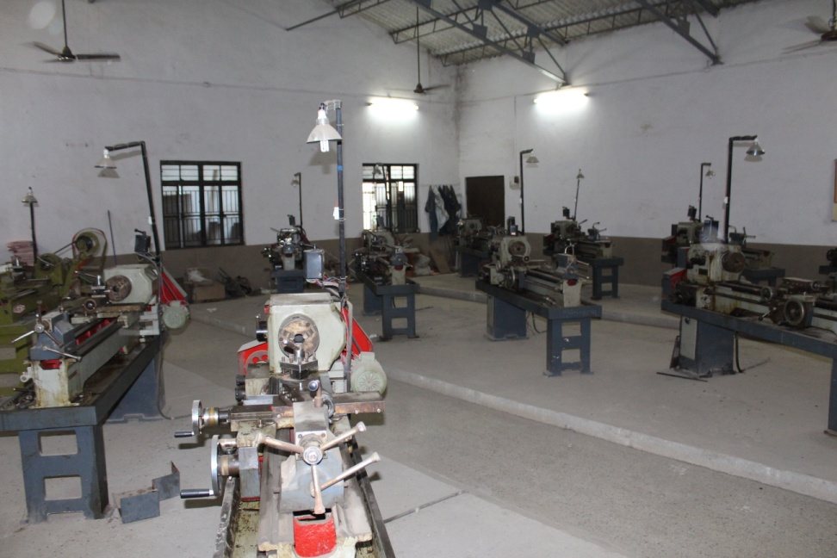
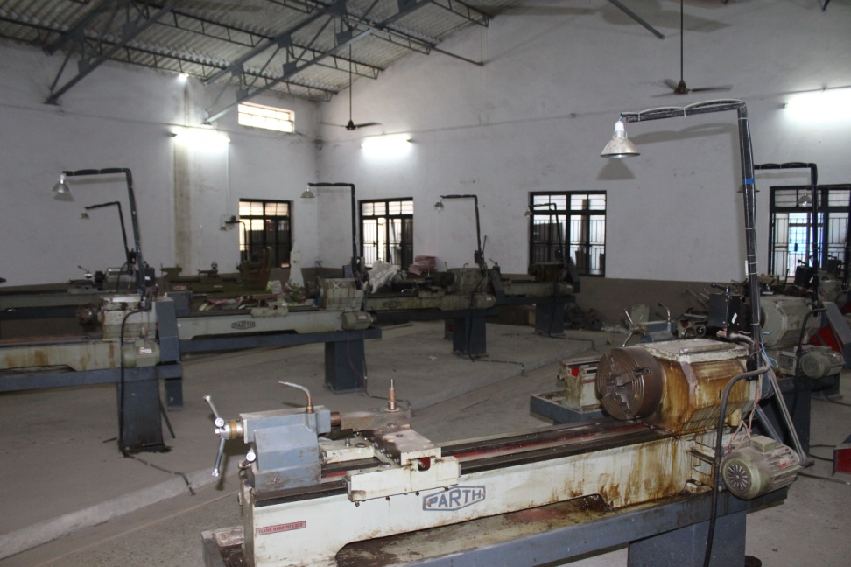
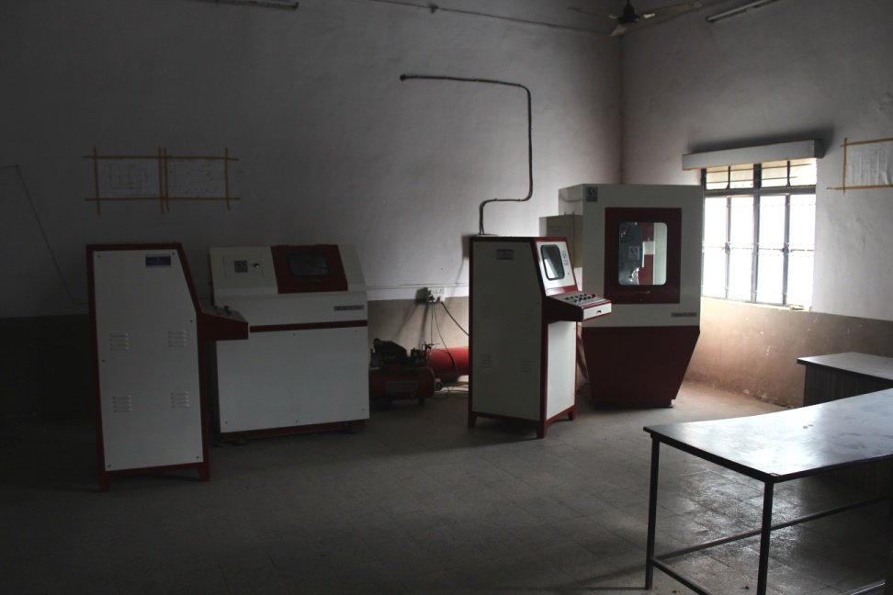

Class Rooms
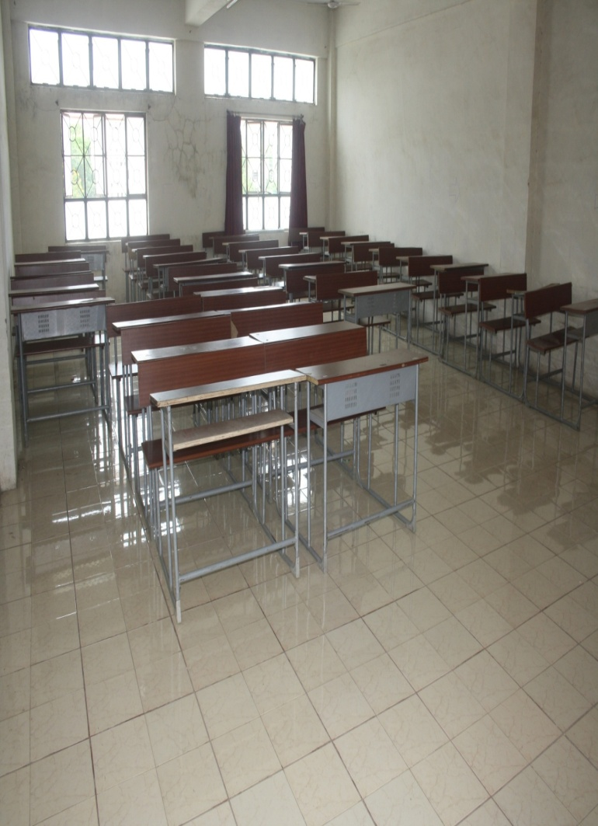
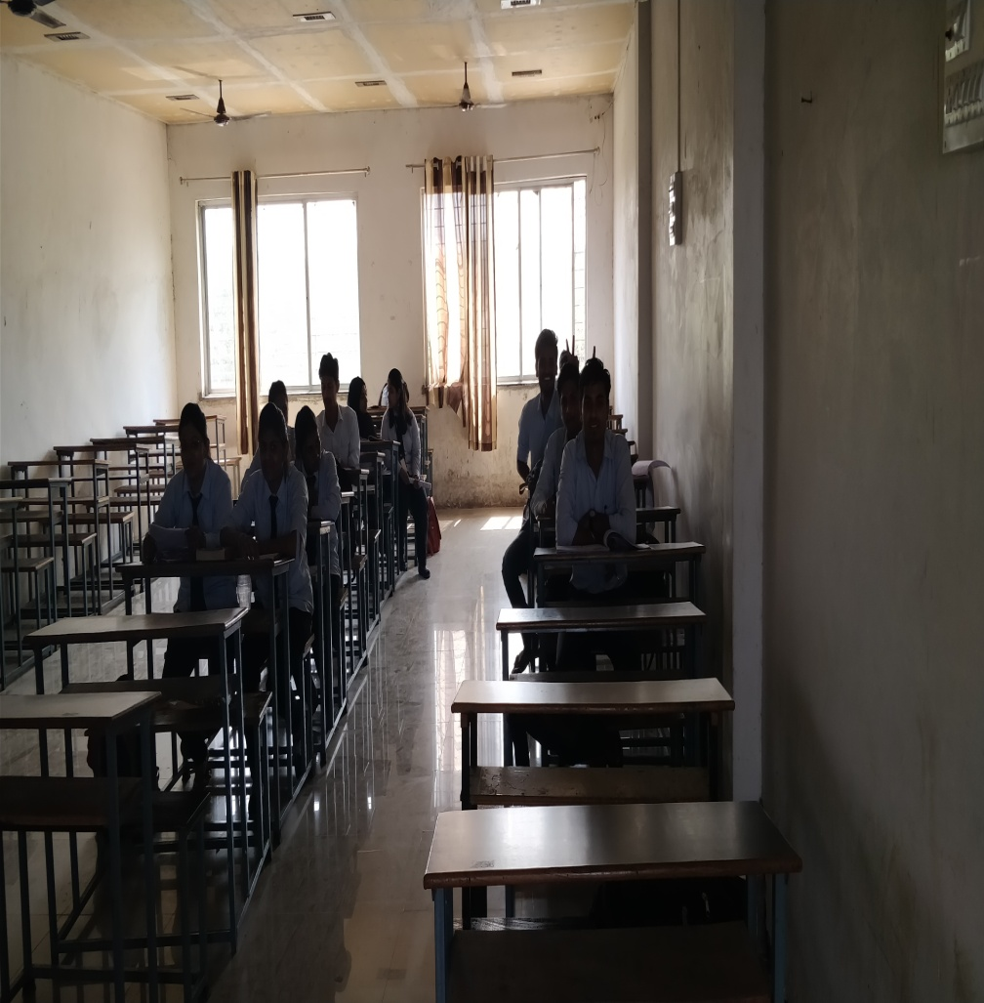

Campus
